**NANDHA ENGINEERING COLLEGE**

**(Autonomous Institution)**

Erode-638 052



**TABLEAU-TWO CREDIT COURSE**

**IV – Semester**

**B.Tech - Artificial Intelligence and Data Science**

**NAME : K.HARSITH**

**REG.NO : 23AI022**

**BRANCH : B.TECH AI & DS**

**YEAR : II**

**TABLEAU**

* Tableau is a data visualization tool.
* Used for analyzing and visualizing data through interactive dashboards and reports.
* Allows easy creation of charts, graphs, and maps.
* Connects to various data sources (Excel, databases, cloud services).
* Helps in identifying trends, patterns, and outliers in data.
* Known for a user-friendly, drag-and-drop interface.
* Supports real-time data analysis and updates.
* Popular in business intelligence and data analysis fields.
* Can be used for both individual and collaborative data analysis.

**OVERVIEW OF THE PROJECT**

The dataset explores the relationship between water pollution and public health across different countries and regions. It records water quality indicators like contaminant levels, pH, turbidity, and oxygen concentration from various sources such as lakes, wells, and ponds. The data links these environmental factors to human health outcomes, tracking cases of diseases like cholera and typhoid, along with infant mortality rates. Additionally, it includes economic and social indicators like GDP per capita, healthcare access, urbanization, and sanitation coverage, offering a complete view of how living conditions interact with water quality.

**WATER CONTAMINANT LEVELS OVER TIME**

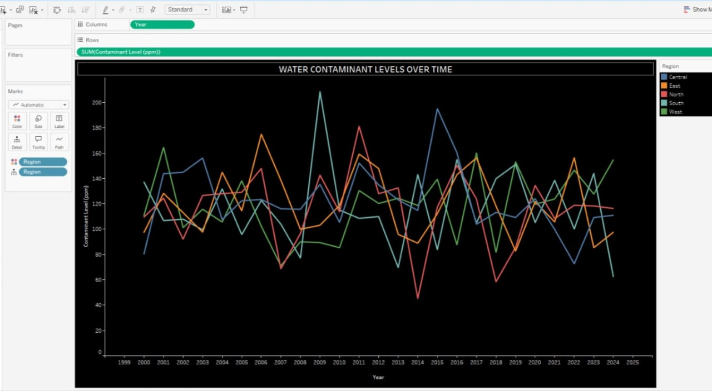

* **Overview:**

The chart shows how water contamination levels have changed over time across different regions.

* **Movement of Lines:**

Each colored line represents a region, moving unpredictably, highlighting unstable water quality without consistent improvement or worsening.

* **Axes Explanation:**

The X-axis (bottom) shows the years, while the Y-axis (side) measures the contamination level in parts per million (ppm).

* **Data Behavior:**

Sharp peaks indicate sudden pollution spikes, while dips suggest possible improvements or interventions.

* **Color Usage:**

Central, East, North, South, and West regions are shown with different colors, making it easy to compare the changes.

* **Visual Impact:**

The black background creates a dramatic and urgent feel, emphasizing the seriousness of the pollution problem.

DISEASE CASES BY REGION

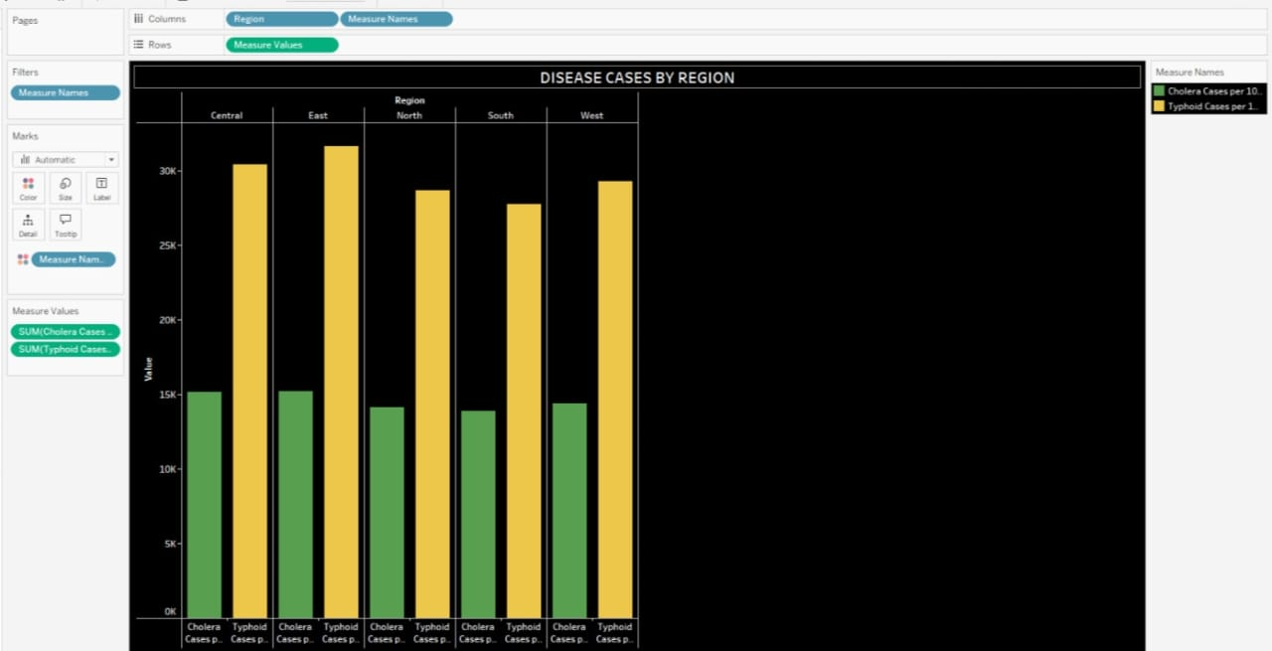

* **Chart** **Overview:**

The chart compares Cholera and Typhoid cases across five regions: Central, East, North, South, and West.

* **X-Axis (Horizontal):**

It displays each region broken into two categories — Cholera Cases and Typhoid Cases.

* **Y-Axis (Vertical):**

It shows the number of disease cases per 100,000 people, with values rising from 0 upwards.

* **Color Coding:**

Yellow bars represent Cholera cases, while green bars represent Typhoid cases — easily distinguishing the two diseases.

* **Trends Seen:**

Across all regions, Cholera cases are consistently higher than Typhoid cases.

* **Visual Style:**

The black background and bright bar colors make differences between Cholera and Typhoid cases visually striking and easy to compare.

COUNT OF BACTERIA IN WATER SOURCE

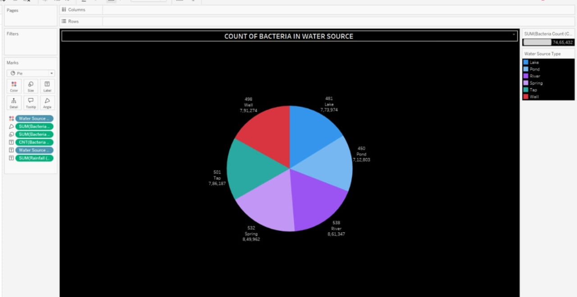

* **Chart Type:**  
   This is a **pie chart** showing the **distribution of bacteria counts** across different water sources.
* **Categories**:  
   The water sources included are **Lake**, **Pond**, **River**, **Spring**, **Tap**, and **Well** — each shown with a different color slice.
* **Data Representation**:  
   Each slice size represents the **total bacteria count** from that water source — larger slices mean higher contamination.
* **Key Findings**:  
   **Spring water** has the **highest bacteria count** (8,49,962), while **Pond water** has the **lowest** (7,12,803) among the given sources.
* **Color Coding**:  
   Each water source type is uniquely colored, and a **legend** is provided on the right for easy identification.
* **Visual Impact**:  
   The **black background** highlights the colorful pie slices well, making it easy to see and compare contamination levels visually.

ANALYZING PH LEVEL AND YEAR

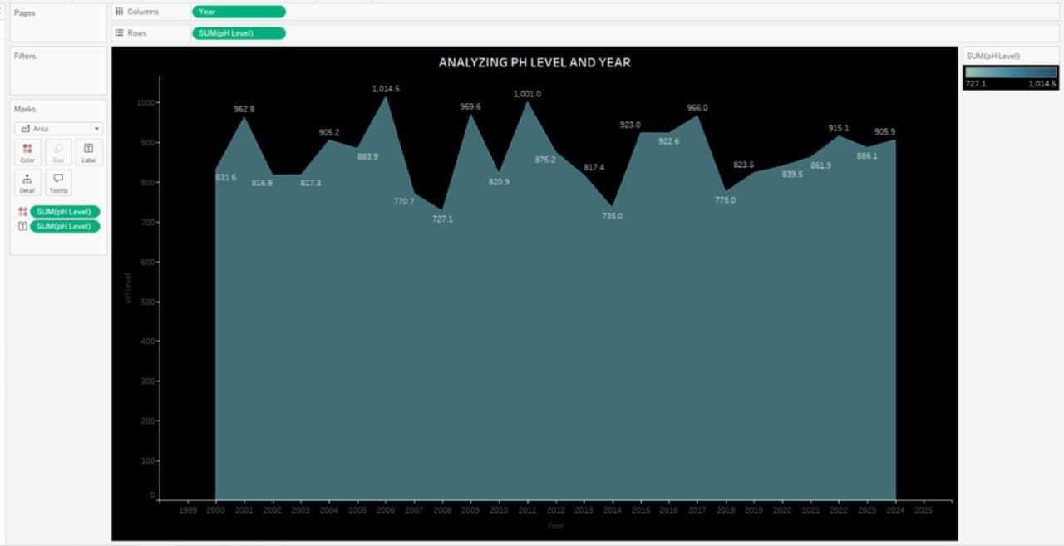

* **Chart Type:**

This is an area chart showing the changes in pH levels over different years.

* **X-Axis (Horizontal):**

It represents the Year, ranging roughly from 1999 to 2025, helping track pH changes over time.

* **Y-Axis (Vertical):**

It shows the Sum of pH Levels, with values rising from 0 to around 1,100.

* **Trend Behavior:**

The chart shows fluctuations — pH levels rise and fall, with peaks around 2005, 2011, and 2017, and dips around 2008, 2013, and 2018.

* **Color and Labeling:**

The teal shaded area represents the total pH level visually, and exact values are labeled on each peak and dip for clarity.

* **Visual Style:**

The black background creates a strong contrast, making the teal pH levels and white text labels stand out clearly for easy reading.

URBANIZATION IMPACT ON CLEAN WATER ACCESS

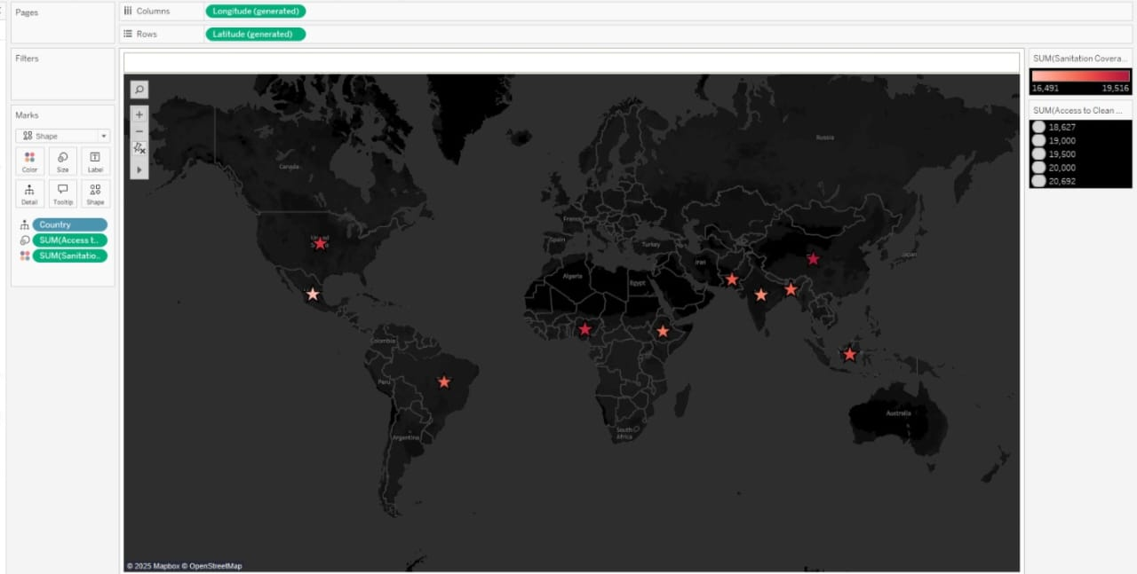

* **Chart Type:**

This is a symbol map that plots countries based on Access to Clean Water and Sanitation Coverage.

* **X and Y Axes:**

The map uses Longitude (X-axis) and Latitude (Y-axis) to place each country geographically on the world map.

* **Markers and Color:**

Stars represent different countries, and the color intensity (from light to dark red) shows variations in sanitation and clean water access — darker shades may indicate worse conditions.

* **Data Values:**

The chart uses two measures:

* Access to Clean Water (people
* Sanitation  
  displayed through the size and color of the star shapes.
* **Regional Insights:**

Countries from Africa, Asia, and South America show prominent markers, indicating significant issues or noteworthy data points related to clean water and sanitation.

* **Visual Style:**

The black background and bright-colored stars make the map highly contrasted, making country locations and sanitation access differences easy to notice.

WATER POLLUTION DISEASES IN TABLEAU

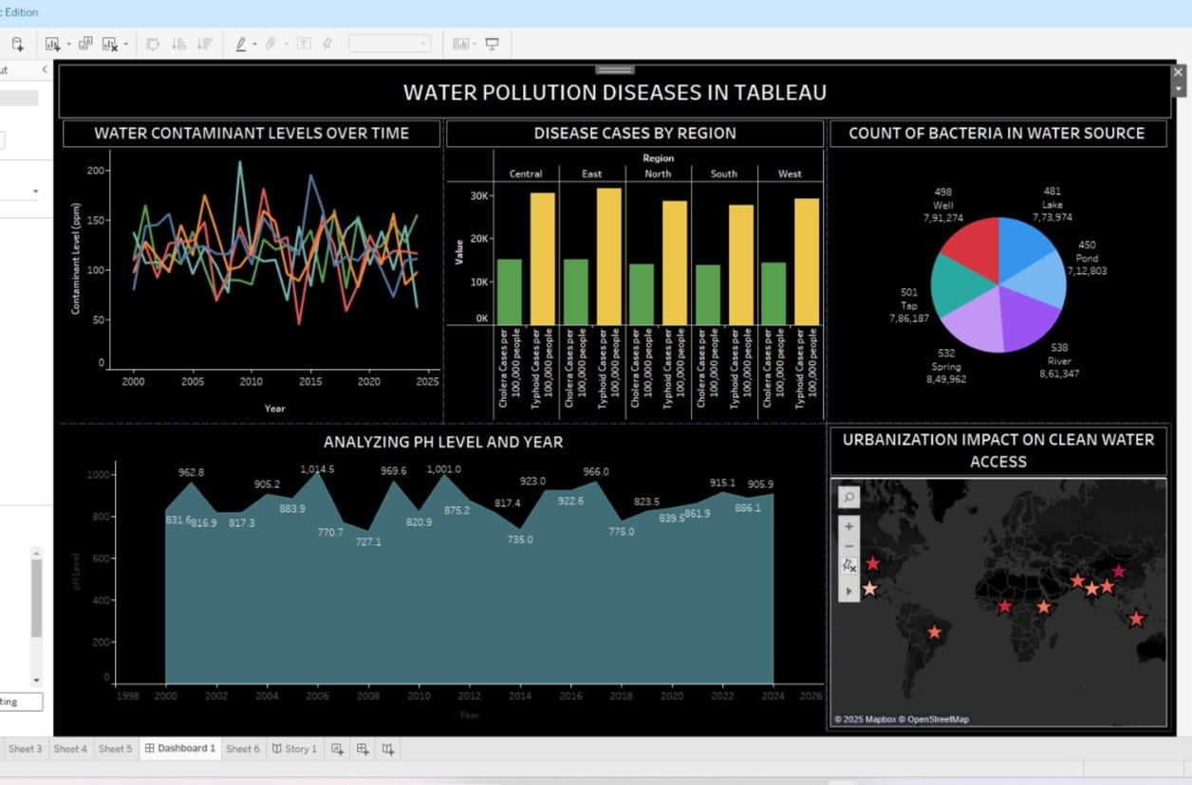

* **Water Contaminant Levels Over Time (Top Left):**

This multi-line chart shows how water contaminant levels (in ppm) have changed over the years across different regions (Central, East, North, South, West).  
🔎 Insight: Contamination levels are highly unstable, with lots of fluctuations but no consistent improvement.

* **Disease Cases by Region (Top Center):**

This clustered bar chart compares the number of Cholera and Typhoid cases per 100,000 people in each region.

🔎 Insight: Cholera cases are higher than Typhoid cases in every region, showing serious public health concerns.

* **Count of Bacteria in Water Source (Top Right):**

This pie chart displays the distribution of bacteria counts across different water sources like lakes, wells, rivers, springs, taps, and ponds.  
🔎 Insight: Spring and Well waters show the highest bacterial contamination.

* **Analyzing pH Level and Year (Bottom Left):**

This area chart tracks the total pH level over time, helping analyze how water's acidity or basicity changed yearly.

🔎 Insight: pH levels rise and fall but stay mostly within a moderate range; sharp peaks and dips indicate water quality instability.

* **Urbanization Impact on Clean Water Access (Bottom Right):**

This world map shows various countries with different levels of clean water access and sanitation coverage based on urbanization impact.

🔎 Insight: Many countries (especially in Africa and Asia) still face limited access to clean water, highlighted by colored star markers.

* **CONCLUSION:**

The dashboard highlights serious water pollution problems across regions.  
High contamination levels are linked to more cholera and typhoid cases.  
Springs and wells show the highest bacterial counts, needing urgent action.  
pH levels are unstable, suggesting inconsistent water quality over time.  
Urban areas in many countries still struggle with clean water access and sanitation.